Lab 6.2: Logical Operators in MongoDB
Student: Sandesh Khatiwada
Date: 12/1/2025

OBJECTIVES:
1. Understand the purpose of logical operators in MongoDB queries.
2. Learn to combine multiple conditions using $and, $or, $not, and $nor.
3. Apply logical operators on a sample collection to filter documents efficiently.

———————————————
GENERAL SYNTAX (REFERENCE)
———————————————
db.<collection>.find(
{
<logical_operator>: [
{ <condition1> },
{ <condition2> }
]
}
)

———————————————
SAMPLE DATA (customer)
———————————————
db.customer.insertMany([
{ _id: 101, name: "Sandesh", age: 23, city: "Sindhuli" },
{ _id: 111, name: "Saisa", age: 22, city: "Pokhara" },
{ _id: 119, name: "Dhiraj", age: 30, city: "Biratnagar" }
])
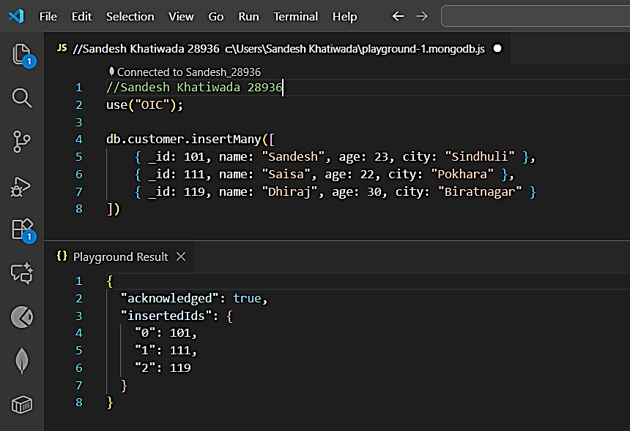

TASK 1:
Find the id and name of the customer whose age is greater than 20
AND the city is Pokhara.

db.customer.find(
{
$and: [
{ age: { $gt: 20 } },
{ city: "Pokhara" }
]
},
{ _id: 1, name: 1 }
)
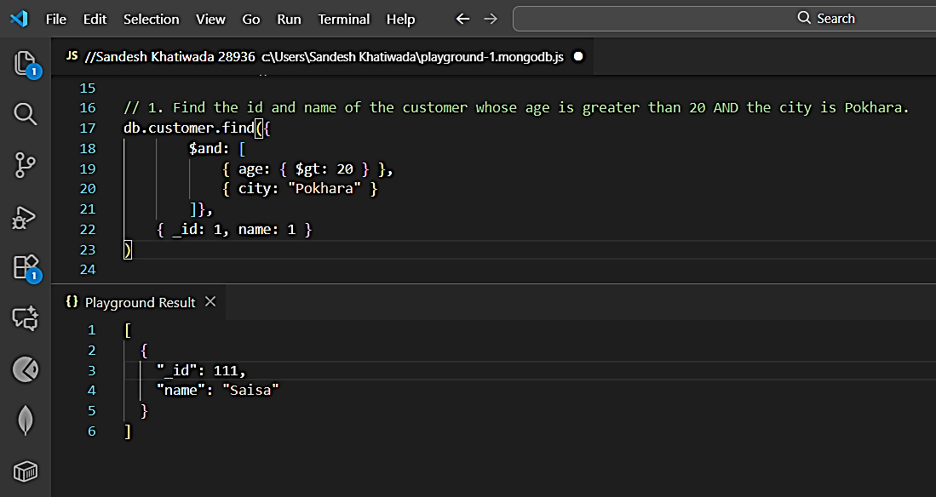

TASK 2:
Find all customers who are either from Kathmandu or Sindhuli.

db.customer.find(
{
$or: [
{ city: "Kathmandu" },
{ city: "Sindhuli" }
]
}
)
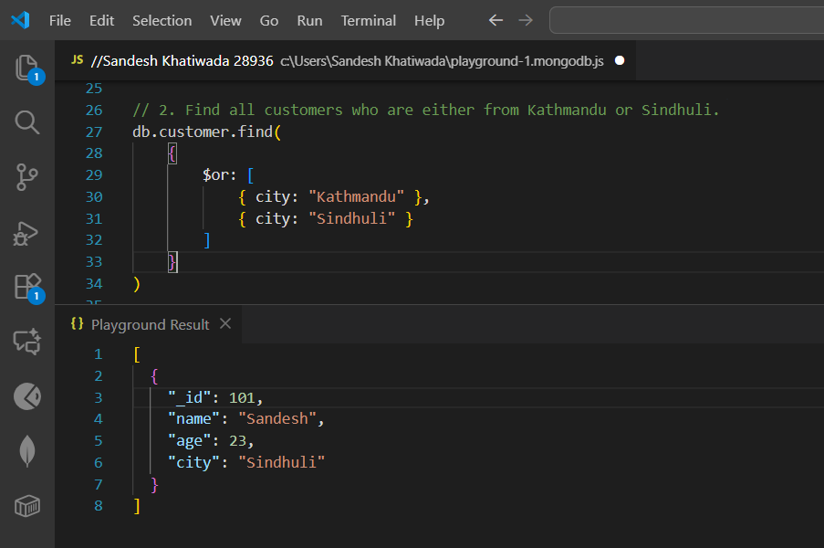

CONCLUSION
Logical operators allow combining multiple conditions in MongoDB queries.
$and, $or, $not, and $nor help refine search criteria and filter complex datasets.
Using these operators makes queries more expressive, flexible, and powerful when working with real-world data.

